Southern Tier Chapter of
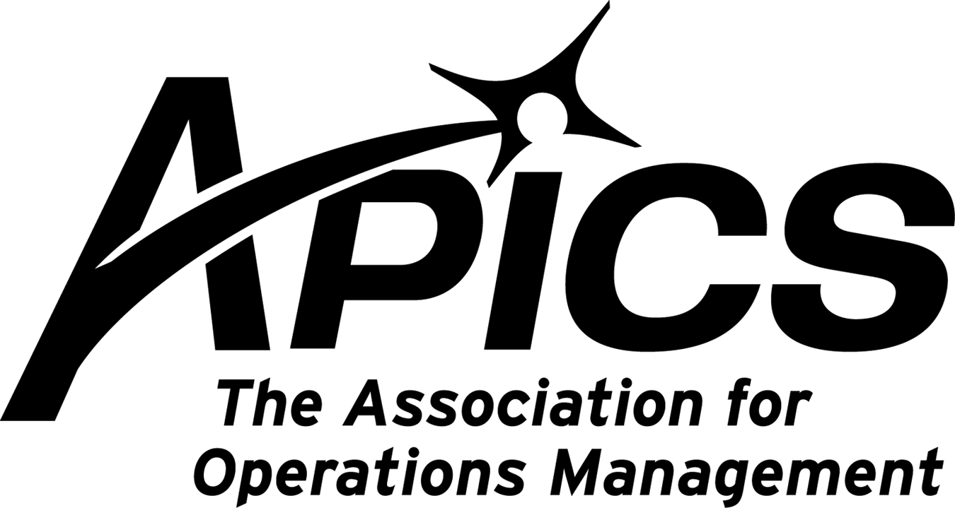
www.stapics.org

“Advancing productivity and innovation and competitive success.”

NO JUNE DINNER MEETING

APICS Members Receive Two Years’ Access to the Aberdeen Vault
APICS is pleased to announce an enhancement to your member benefits. APICS members can receive two years of free access to the Aberdeen Research Vault, providing you with an exclusive look at the latest Aberdeen analysis, market-moving news, and vertical insights—a $995 value. Take advantage of this member benefit by registering for the Aberdeen Vault today.
Access the Aberdeen Vault in Three Easy Steps
1) Go to this link to sign on to the Aberdeen Group web site: http://vault.aberdeen.com/public/check-identity/vault/47573ySDXH/partner.aspx
- For existing Vault members who wish to extend membership: Enter your user name and password.
- For new Vault members: Enter your email address under "New Registration" and click "Enter."
2) Enter APICS VIP Promotional Code: 67845WJDYP in the box at the top, and click "Validate Code."
3) After validating the code, the registration cost should change to zero dollars. You now are ready to complete your account profile and begin accessing the full research library. Be sure to bookmark the site so you can find it easily in the future.
Resource: APICS May 2010 Connection Newsletter

APICS - New Date & Location for 2010 APICS International Conference

After an extensive search, APICS is pleased to announce a new location for the APICS International Conference & Expo has been secured.
Las Vegas will host the conference, which will now begin on Monday, October 18.
2010 APICS International Conference & Expo
New Date! Monday, October 18–Wednesday, October 20, 2010
Wynn Las Vegas
Las Vegas, Nevada, USA
The Volunteer Leadership Workshop will be held on Sunday, October 17.
More details to follow.

If you are unemployed, APICS will extend your membership at no cost to you.
Contact us if you need our help.

Northeast District Meeting

“APICS BOK and Supporting Products”

June 4th and 5th, 2010

Portland, Maine

Marriott Portland At Sable Oakes
200 Sable Oakes Drive
South Portland, ME 04106
(800)752-8810 or (207) 871-8000
www.marriottsouthportland.com.

Your 2010-2011 Board of Directors

President / VP Education Dave Gardner dgardner@akraturn.com
VP Membership / Website Lee Schechter lschechter@stny.rr.com
Executive VP / Director of Finance Steve Whited steve.whited@mwv.com
Director of Education Don Sheldon dsheldon@stny.rr.com
Publicity / Marketing / Programming Michael LoSapio Michael.losapio@synergyresources.net
Marketing Director Kelly Norieka Kelly.norieka@lmco.com
Secretary Deb Unkel deb.unkel@raymondcorp.com

Southern Tier APICS
PO Box 1107
Binghamton NY 13902-1107

